Structural Diagrams

Group name : Non-bug Coding

Members :

Wenhao Yang 100991599

Moonseok Choi 101011578

Component Architecture

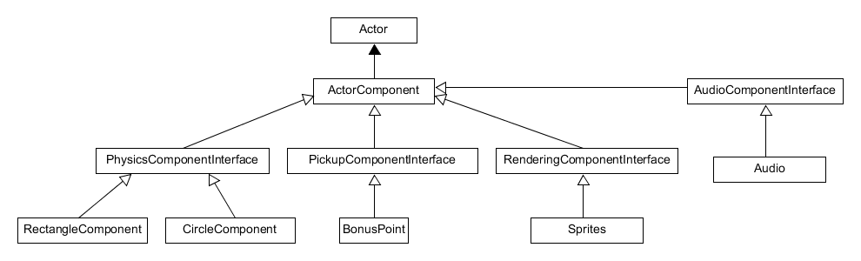

Engine Class

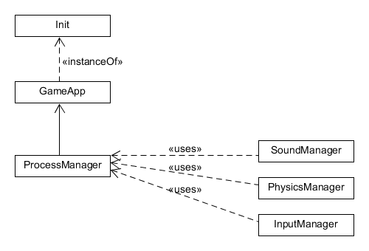

Main Loop

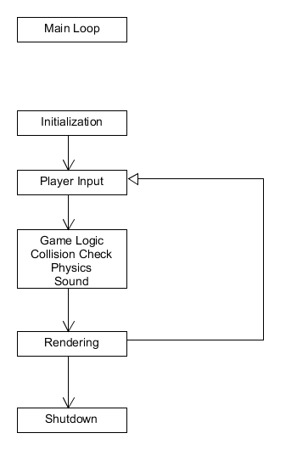

The game loop is formed in simple loop style. Every tick, everything is updated.